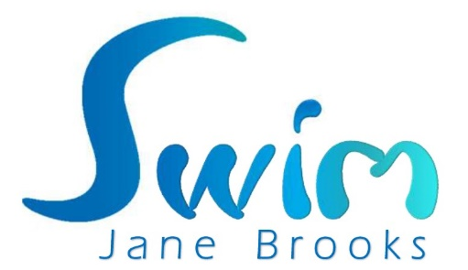

Swimming Teacher Application Form
- PERSONAL DETAILS:

Full Name: _____________________________________________ Title: __________

Date of Birth: _____________________________

Home address: ________________________________________________________

_____________________________________________________________________

Postcode: ______________________

Home Tel no: __________________________ Mobile Tel no: ___________________

Email Address: _________________________________________________________

- APPLICATION FOR THE POST OF:

Post you are applying for: ________________________________________________

Are you a member of Swim England, IOS or STA? _____________________________

- EDUCATION, QUALIFICATIONS & TRAINING (list most recent first):

Name of school/ college/university /training body | Dates: |  | Qualifications gained/examinations passed/grades
 | From | To
Please list any memberships you hold:

Membership Body: | Registration Number: | Date Obtained:
- RELEVENT EMPLOYMENT RECORD (Other coaching/teaching positions):

Name of employer: __________________________________________________________

Address: __________________________________________________________________

Position held: ______________________________________________________________

Summary of duties/responsibilities: ____________________________________________

_________________________________________________________________________

Date left if no longer employed: _______________________________

Reason for leaving: _________________________________________________________

- DBS CHECKS:

Do you have a current DBS? YES/NO

DBS Document Number: _____________________________________________________

Date of Issue: ________________________________

- SUPPORTING INFORMATION:

Please use the space below to give us further details of your career, activities and personal interests which you think are relevant to your application.

- REFERENCES:

Please give details of two referees.

- Referee (present/last employer) Name: ______________________________________

Address (inc. company name): _________________________________________________

Occupation: _______________________________________________________________

What is your connection with this referee? _______________________________________

Contact telephone number: ___________________________________________________

Contact email address: _______________________________________________________

May we obtain a reference prior to an offer of appointment? (yes/no) ________________

- Referee (present/last employer) Name: ______________________________________

Address (inc. company name): _________________________________________________

Occupation: _______________________________________________________________

What is your connection with this referee? _______________________________________

Contact telephone number: ___________________________________________________

Contact email address: _______________________________________________________

May we obtain a reference prior to an offer of appointment? (yes/no) ________________

I certify that, to the best of my belief, the information I have supplied is true and complete and that I possess all qualifications listed on this form. I understand that any false information or failure to disclose relevant medical details, criminal convictions or prosecution pending may disqualify me from employment or render me liable to summary dismissal.

Signature: _________________________________ Date: __________________________

- RETURNING YOUR APPLICATION:
Please return your application form to Jane Brooks either by post to the address below or via email to info@janebrooksgymandswim.com

Return address: 54 Fernhill Road, Begbroke, Kidlington, Oxford, OX5 1R

